)

WebInterpoint User Guide

Service Overview

Last Revised 3/23/11

Table of Contents

Overview 3
System Requirements 4
Scheduling a Conference with Outlook 5-8
Logging In 9
Starting a Session 10-11
Participants Joining the Session 12
Publishing a Document(s) 13-16
Presentation Tools
Navigation Tools 17
Annotation Tools 18
Application Sharing 19-21
Participant Control Features
Send File to Participants 22-23
Edit Participant Information 24
Make Presenter (Multiple Presenters) 25
Remote Control 26-27
Disconnect a Participant(s) 28
Manage Participant Rights 29
Inviting Participants to a Conference 30-31
To Lock a Conference 32
Hand Raise 33
Polling 34-38
Chatting 39-41
On Demand Recording 42-45
Ending a Conference 46

**Tutorial Videos: http://support.infiniteconferencing.com/webinterpoint_tutorials.htm**

Overview

This guide provides the basic information necessary to start a WebInterpoint Web Conference. Please review the system requirements to ensure you have everything you need to get started. If you need additional assistance getting started or if you do not yet have an account, contact Infinite Conferencing at:
1.888.203.7900
1.973.671.0040
clientcare@infiniteconfrencing.com
ops@infiniteconferencing.com

System Requirements

Host and Participant systems must meet the following minimum requirements:
- Network connection to the WebInterpoint 8.3 server through HTTP and HTTPS
- Internet connection speed of 128 Kbps or higher - see bandwidth considerations below
- Microsoft Windows 7/XP/Vista or Server2003/li
- Internet Explorer 6.0 SP2, 7.0 and 8.0, Firefox 3.0x/3.5
- Mac OS X 10.5/10.6 with Firefox 3 or Apple Safari 4.x, 5.x
- Linux, Unix, or Solaris with Firefox 1.0+
- Cookies and Scripting enabled in browser

Average Bandwidth Usage
- Application Sharing- 240 Kbps/participant (Note: Medium quality with average UI screen updates)
- Published Files- jpeg/html download rate is proportional to the available bandwidth

Host a Meeting: Feature Requirements
- Application Sharing for Microsoft Windows - A small ActiveX component is required for Hosts to share applications from their Microsoft Windows desktop. If the component is not present on the Host’s system, they will be prompted to download it. If system security settings prevent you from downloading and installing ActiveX components, you can obtain the component by downloading and installing the WebInterpoint 8.3 Options Kit.
- Application Sharing for Mac: Sharing components are automatically delivered via Java.
- Recording- Apple QuickTime Player or Windows Media Player for playback of .MOV or .WMV recordings

Participate in a meeting: Feature Requirements
- Application Sharing – Java Version 1.5 greater is needed for this feature.

Scheduling a Conference with Outlook

WebInterpoint 8.3 Microsoft Outlook TM Integration allows a Host to schedule web conferences using Microsoft Outlook. Adding web conferencing to an Outlook meeting is as simple as clicking the WEB CONFERENCE icon in a Microsoft Outlook Calendar Appointment or Meeting Request.

To schedule a conference using Outlook:

- Install the Outlook Add-On by downloading and installing the latest plug in and selecting the "Microsoft Outlook Conference Scheduling Add-on" option during installation (Figure A).
- Note: You must temporarily close Outlook while installing this feature.

Feature A
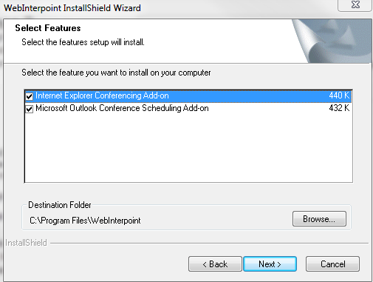

- Access the scheduling feature of Outlook. From the calendar feature in Microsoft Outlook, open a calendar appointment or Meeting Request. You may do so by selecting the FILE menu, next select NEW, and then APPOINTMENT or MEETING REQUEST. You may also create a new appointment by double clicking on a specific date and time on your calendar. An Outlook Appointment or Meeting Request dialog window will open (Figure B).

Figure B
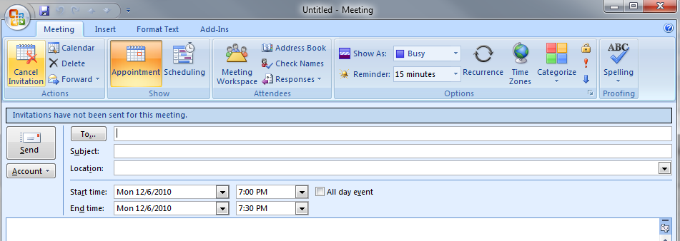

- Insert e-mail addresses and meeting details just as you would through the Meeting feature of Outlook.

- Set a Reminder for your web conference so you will be able to login before the conference is scheduled to begin.

- Click the WEB CONFERENCE Icon at the upper left-hand corner of the Outlook appointment window. (You might find this by clicking on the Add-Ins tab-Figure C). This will open a Web Conference Details window (Figure D).

Figure C
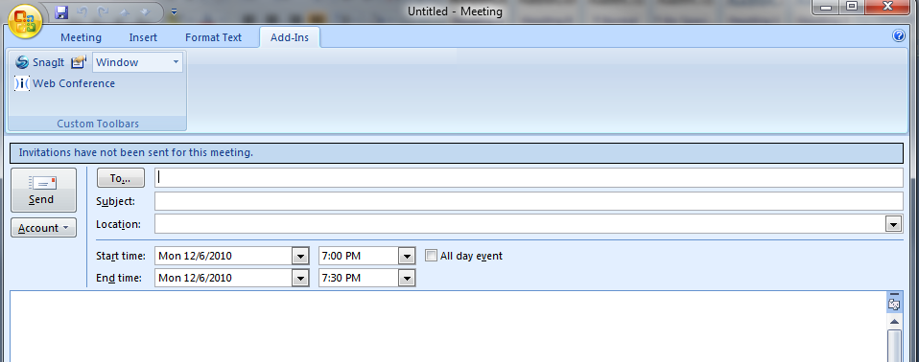

Figure D
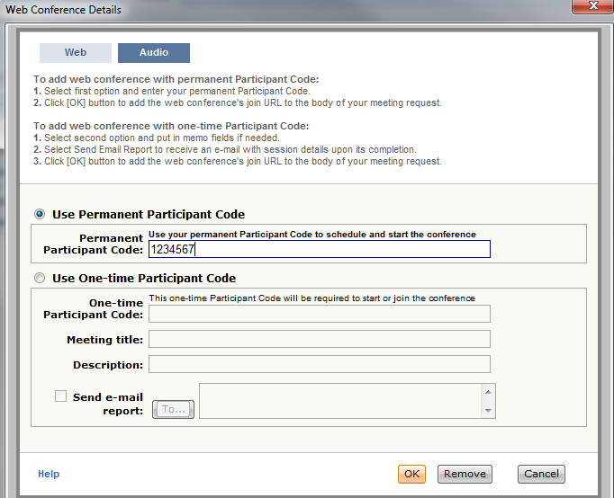

- Ensure that your Web conference account information is correct in the fields provided. This is the information that you will be sending to your participants.

- Click the OK button (Figure D), which will insert the meeting link and dial-in information into the body of your meeting request (Figure E).

Figure E: It will automatically populate the following information in your email.
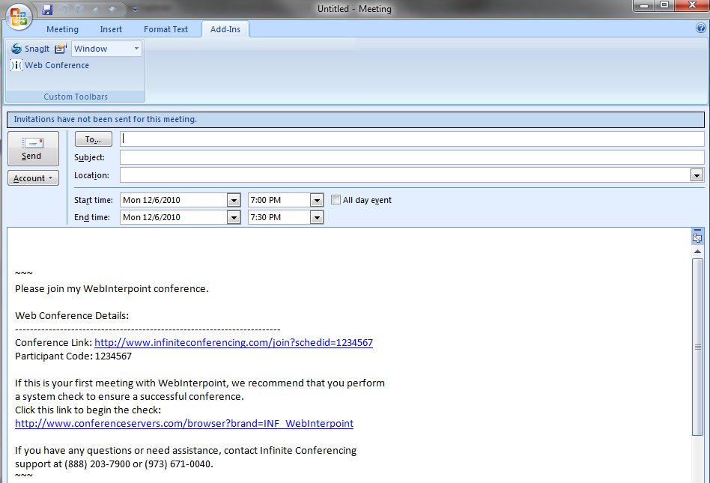

- At meeting time, the Host then clicks the embedded link, which opens the log in page for the conference. To login, the Host inserts his or her credentials.
Note: In order to allow participants to join, the Host must login before the meeting is scheduled to begin.

Log In

Begin using your WebInterpoint account by opening the Join page at http://www.infiniteconferencing.com/join. There are separate login forms for hosts and for participants. To host a conference, click on the host radio button, represented in Figure A, using the Chair Code and Participant Code you received either through email or the wallet card. Figure B represents the form used for participants to login to conference. Participants will use the participant code to join.

Figure A: Host a meeting.

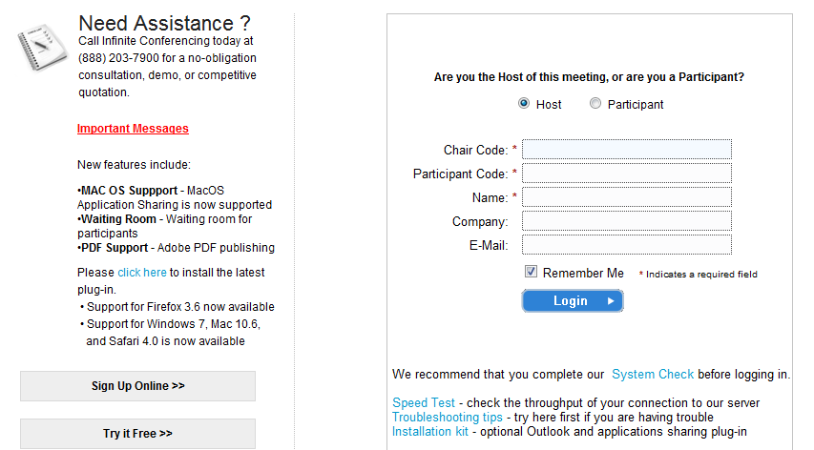

Figure B: Join as a Participant.

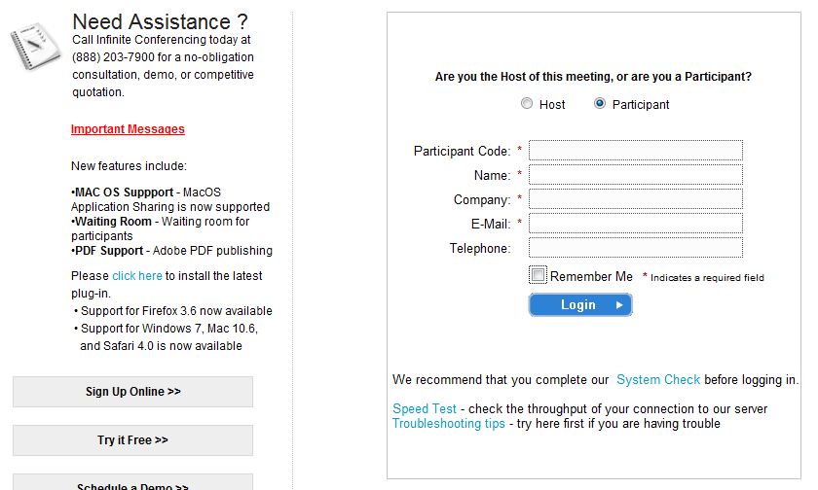
Starting a Session

- After you log in you are presented with a conference window (Figure A). At the top of the conference window there is a toolbar containing buttons used to conduct and manage Web conferences.

NOTE: Participants cannot log in until the host starts the conference.

Figure A: The conference window that appears as soon as you log in.
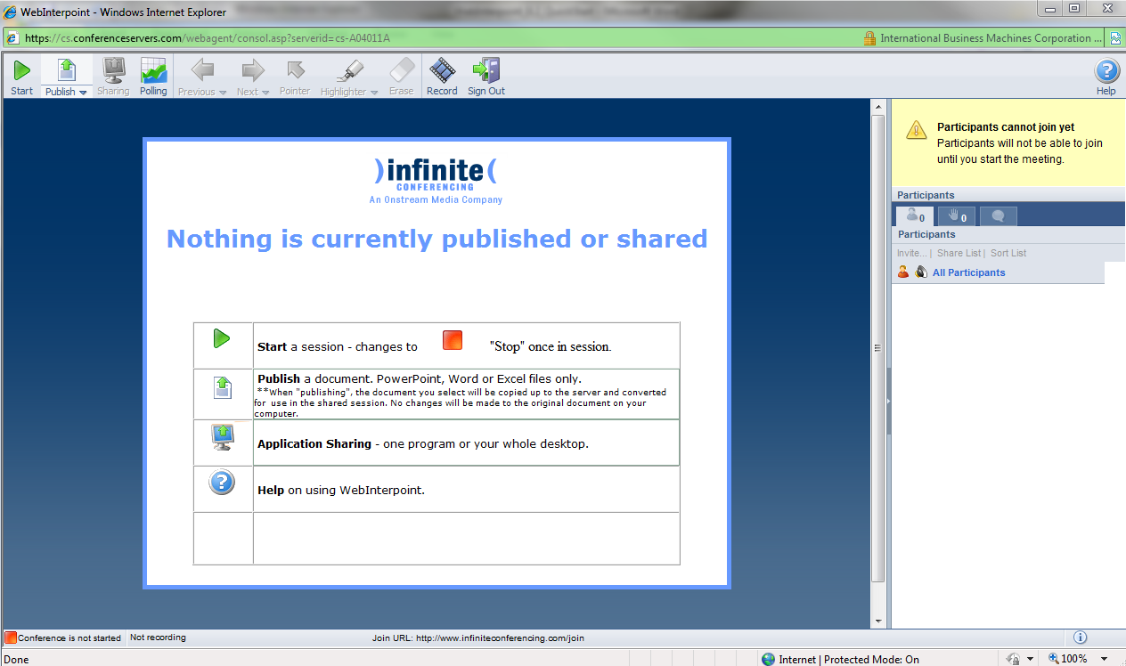

- Since WebInterpoint does not require pre-planning or scheduling, once you have logged into your account, you can immediately start a conference. Click the START button on the toolbar. A dialog window opens displaying instructions for you to enter the email address where the attendance report will be sent (Figure B). Two boxes are provided to enter Billing Memos. These memos are for client reference only and can be seen on the post conference usage report that will be sent if the “Send a report when the meeting ends” box is checked and the correct email address is entered (Figure C). Notice that once you have started the session, the tool bar will add colors to the icons (Figure D).

Figure B: Dialogue window where you enter your address and billing memos.
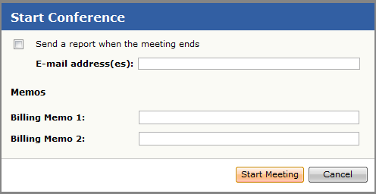

Figure C: Attendance Report
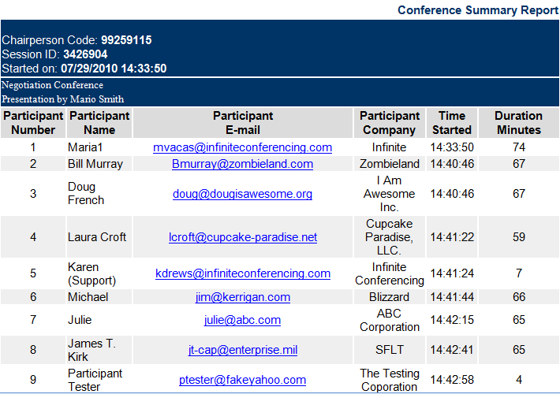

Figure C: The tool bar appears with colors after you start your session.

Participants Joining the Session

- Instruct participants to visit the Join page (http://www.infiniteconferencing.com/join) and to complete the “Login” form using the Participant Code that you provide them with from the start dialog window.
- As each user logs in to the conference, the user’s name appears in the Roster (Figure A).
- The attendee list can be sorted by Name or by Entry Time by clicking ‘Sort List’ then choosing the sort option you prefer (Figure B).

Figure A: List of Attendees Figure B: Sorting your attendee list
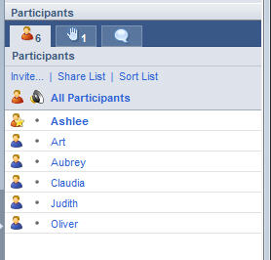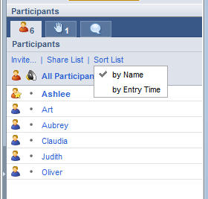

- There is a different toolbar that will appear for participants that will only include very few options (Figure C).

Figure C: The toolbar that displays for participants
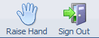

Publishing a Document(s)

Once you have logged in to your WebInterpoint session you can prepare for a conference by publishing Microsoft® PowerPoint®, Word, Excel, or PDF documents.

Publishing Documents:

- Click the PUBLISH button on the presenter toolbar and click on MANAGE PUBLISHED FILES (Figure A).
- Click BROWSE from the “Publish a File” dialog window (Figure B).
- Select a document file path using the file explorer window.
- Click the UPLOAD button in the “Publish a File” dialog window (Figure C).
After you complete these steps, your document is automatically copied and converted into a WebInterpoint presentation and saved into the presentation library. A status bar indicates the publishing progress. Once publishing is complete, the first page of your document appears in the conference window.

Figure B
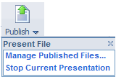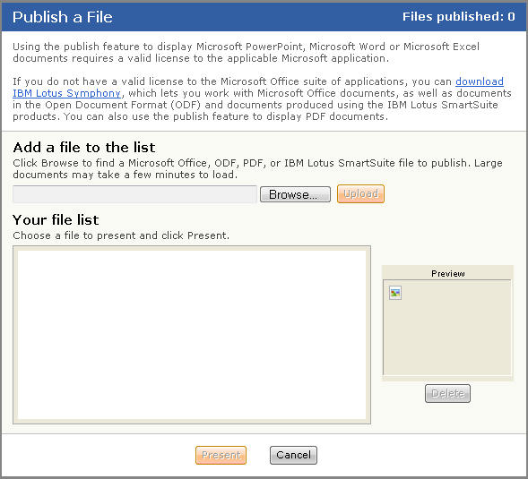
Figure A

Figure C
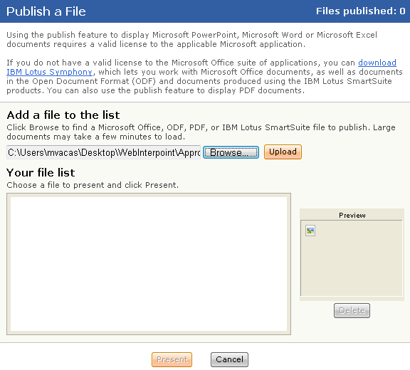

Presenting Previously Published Documents:

- Click on the PUBLISH button on the presenter toolbar.
- The “Publish a File” window will appear, click the radio button next to the file you wish to present from the titles in “Your file list” (Figure D).
- Click the PRESENT button (Figure D).

Or
- Click the PUBLISH sub-menu  located on the lower right of the button. A Drop Down menu will appear. (Figure E.)
- Click the Thumbnail of the file you wish to present.

Once the presentation is chosen, the first slide of presentation will appear on the presenter and participant windows.

Figure D
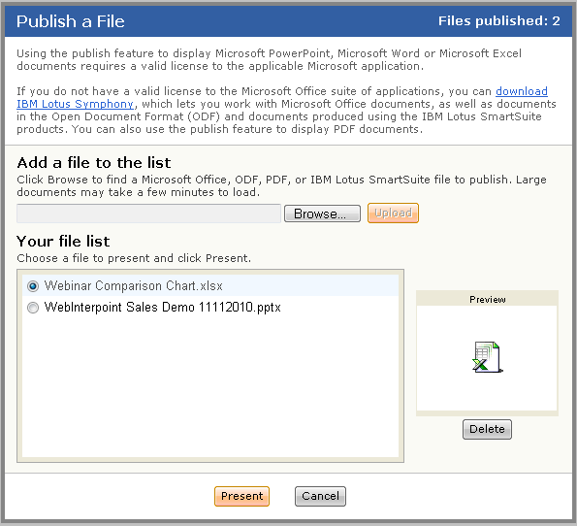

Figure E
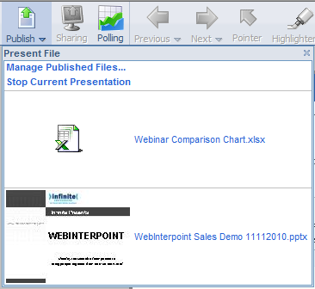
Thumbnails of existing presentations will appear

Deleting a Presentation:

You may choose to delete a presentation anytime in the future using the PUBLISH feature.

- Click the PUBLISH button on the toolbar.
- Select the presentation in the Published Documents list.
- Click the DELETE button (Figure F).

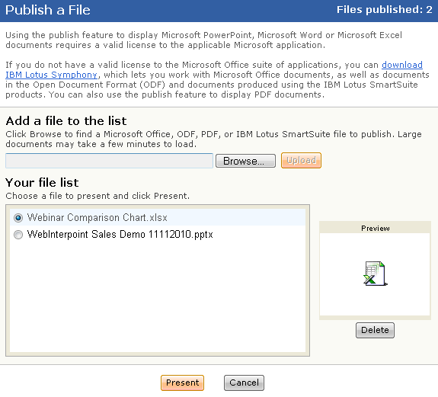
Select the file from the list that you want to delete

Presentation Tools
There are few presentation tools available in WebInterpoint that are useful when trying to create a dynamic presentation for your audience. These features are: Navigation Tools, Pointer, Highlighter and an Eraser.

Navigation Tools

- Use the PREVIOUS and NEXT buttons on the toolbar to index slide by slide through a presentation, document sections or worksheets.

- Use the “Next Slide” and “Previous Slide” submenu(s) to jump directly to a specific slide (Figure A & B).

Figure A Figure B
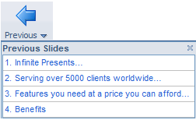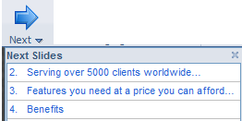

Annotation Tools

Use the POINTER button to toggle the Pointer tool on and off when you want to stamp the content of your presentation in real time or point to items on the screen (like people are seeing their mouse) (Figure C).

-To turn off the pointer, click the POINTER button again.
-To clear the annotation, advance to the next slide or hit the ERASE button.

Use the HIGHLIGHTER button when you want to annotate the content of your presentation in real time (Figure C).

-Choose from 15 highlighter colors by clicking on the down arrow on the HIGHLIGHTER button.
-To turn off the highlighter, click on the HIGHLIGHTER button again.
-To clear the annotation, advance to the next slide or hit the ERASE button.
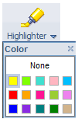
There are 15 color options for the highlighter
Figure C
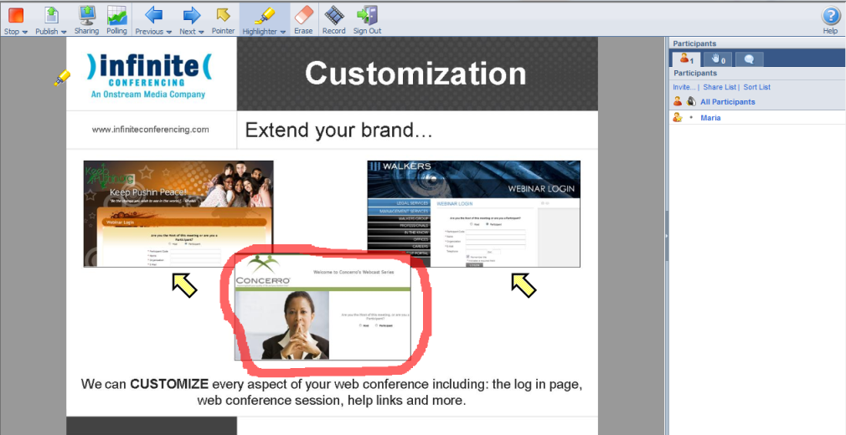
Application Sharing

The SHARING button allows you to share specific applications or your entire desktop, thereby enabling your participants to view changes as you make them and to see applications unique to your desktop. Once you click the SHARING button you will receive a dialog box that shows a list of your currently running applications (Figure A). The host may choose to share the entire desktop or specific applications.

Note: The Application Sharing feature requires the host to install a plug in either beforehand or when prompted to do so. If the host wants to install it beforehand then they can find it on www.infiniteconferencing.com/join.

Figure A
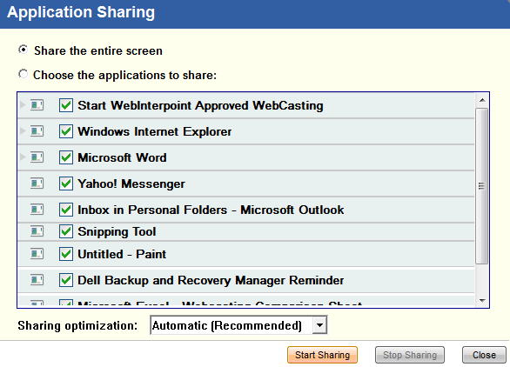

To Share an Individual Application:

- Select the “Choose the applications to share” button.
- Select one or more applications from the list by selecting the box next to the active application(s).
- Click START SHARING.

To Share All Applications:

- Click the “Share the entire screen” button.
- Click START SHARING.

To Stop Sharing:

- Open/restore the WebInterpoint application window (Figure B).
- Click the STOP SHARING button.
Or
- Click the SHARING button from the toolbar to turn sharing off.
Or
  - Click the STOP SHARING button from the toolbar that becomes visible when you start sharing on the top of the screen (Figure C). You have to scroll your mouse to the top for this toolbar to appear.

Figure B
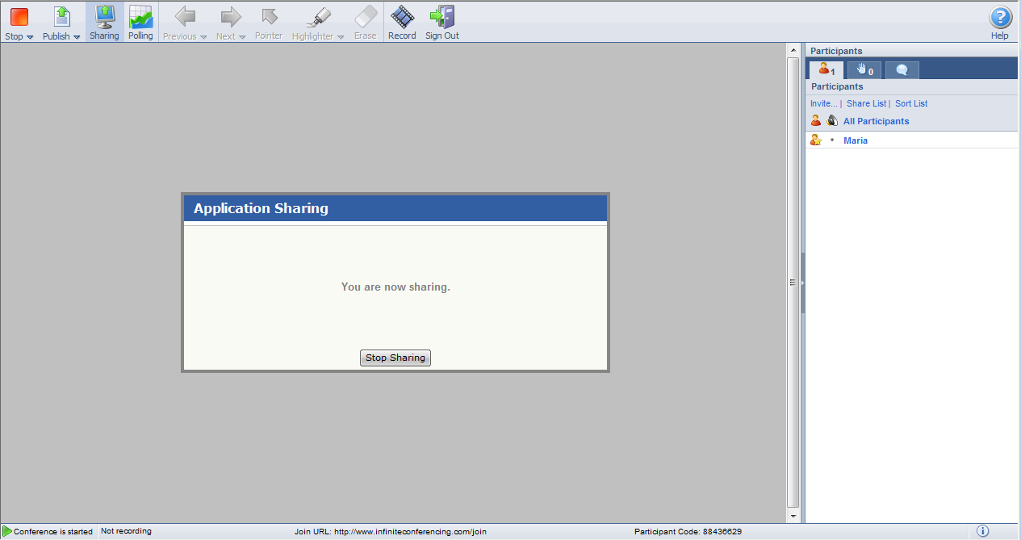

Figure C
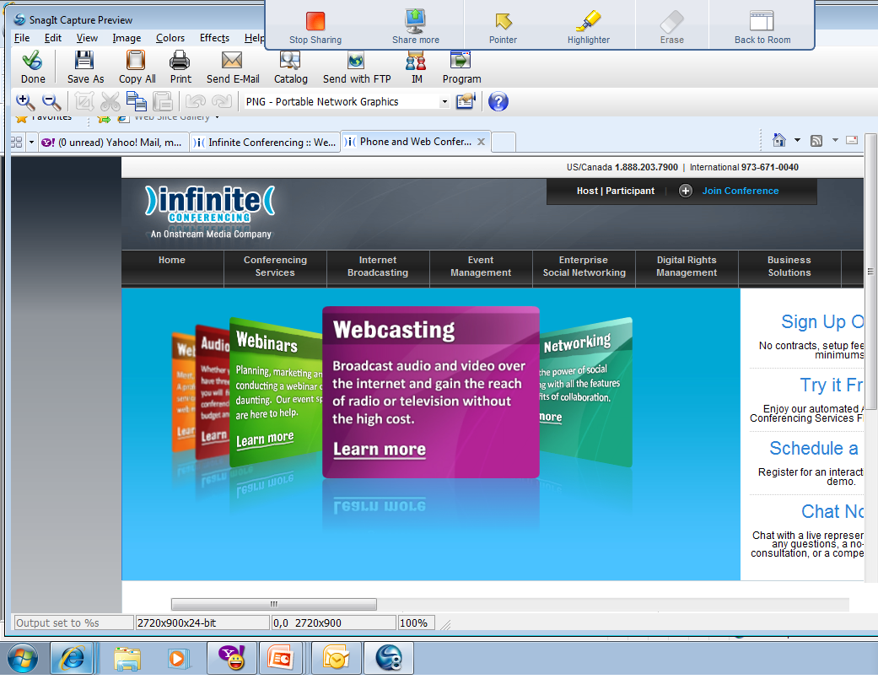
Participant Control Features

The Host has the ability to control several features for participants. These features include: Send File, Edit Info, Make Presenter, Remote Control, Disconnect and Manage Rights to allow participants to see the Attendee Roster and Chat Questions. You can choose to use these features for ALL participants at once or any individual participant.

Send File to Participants

- Click on either the ALL PARTICIPANTS or an individual participant’s name, and choose the SEND FILE button (Figure A).
- A dialog window will appear allowing you to browse for the file you would like to send (Figure B). Once you select the correct file click the SEND FILE button.

Figure B
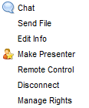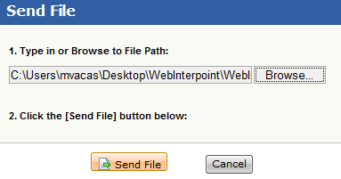
Figure A

- When the transfer has been complete, you will get a dialog window that states Sending File is Complete (Figure C & D).
- Participants will see a link to download the file in their chat window (Figure E).
Figure D

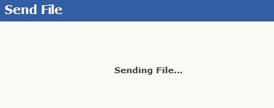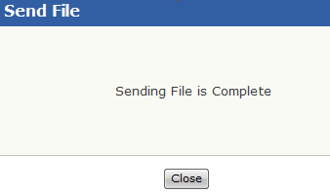
Figure C

Figure E
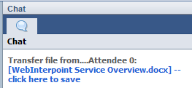

Edit Participant Information

- Click on the individual participant’s name, and then choose the EDIT INFO button (Figure A).
- A dialog window will appear allowing you to change the Name, Company, E-mail and Phone of the participant. (Figure B).

Figure A Figure B
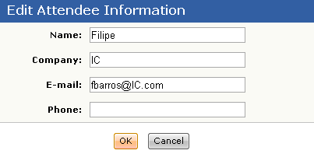

Make Presenter (Multiple Presenters)

WebInterpoint allows you to have multiple presenters by passing the control to participants while in session.

To transfer control to a participant:

- Click the Participant’s name in the Roster.
- Choose MAKE PRESENTER (Figure A). The participant will now have full control of the presentation and will see the complete host toolbar.
- You will view a participant tool bar because it only permits one person at a time to be the presenter (Figure B).

Figure A
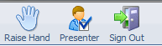
Figure B

To regain control of the application:

- Click on the PRESENTER button from the toolbar to regain control (Figure C). Presentation control is taken back by the original host of the conference. The participant that had control is now only a participant again.

Or

- The current presenter can give you the control again by clicking your name from the roster list and selecting MAKE PRESENTER.

Figure C

Remote Control

This will allow you to have mouse and keyboard function of the participant’s computer.

- Click on the individual participant’s name, and then choose the REMOTE CONTROL button (Figure A).
- Once you click the REMOTE CONTROL button, the participant will receive a dialog box that shows a list of their currently running applications (Figure B).

Note: The Remote Control feature requires the host to install a plug in either beforehand or when prompted to do so. If the host wants to install it beforehand then they can find it on www.infiniteconferencing.com/join.

Figure B
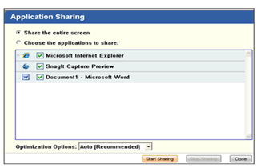
Figure A

To get control of an individual application:

- Select the “Choose the applications to share” button.
- The participant will select one or more applications from the list by selecting the box next to the active application(s).
- Click START SHARING.

To share all applications:

- The participant will click the “Share the entire screen” button
- Click START SHARING.

To regain control of the application:

- Click the Participant’s name in the Roster and choose STOP REMOTE CONTROL (Figure C).

Figure C
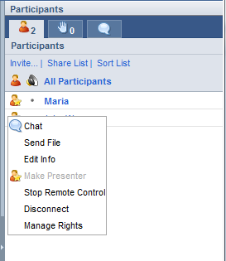

Disconnect a Participant(s)

- Click on either ALL PARTICIPANTS or an individual participant’s name, then click the DISCONNECT button (Figure A).
- A dialogue box will appear confirming that you want to disconnect, click OK (Figure B).

Figure A
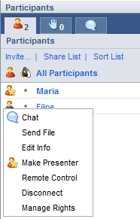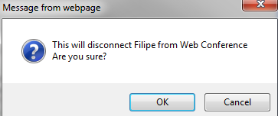
Figure B

Manage Participant Rights

You can also allow a participant to see the attendee roster or chat questions by managing their rights.

- Click on either ALL PARTICIPANTS or an individual participant’s name, and then click on the MANAGE RIGHTS button (Figure A).
- A dialog window will appear giving you the ability to select to give participants rights to see the participant list or receive all Q&A messages (Figure B).
- To allow the rights, check one or both of the check boxes and click the OK button.
- The chosen participants will be able to see the participant roster and chat questions sent to the Q&A group.

Figure A

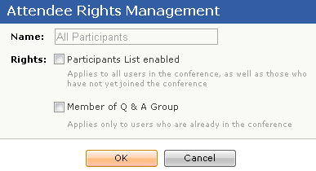
Figure B

Rights Options:
- Nothing checked off: Participants can only chat with Q&A person; in this case the default is the host.
- Participants List Enabled: Participants will be able to view each other and chat with each other.
- Member of Q&A Group: Allows participants to chat with each other, view each other’s Q&A questions, and answer them as well.

Inviting Participants to a Conference

You can invite Participants by giving them the Join URL and Conference ID, which are shown at the bottom of the conference window. However, to invite Participants quickly, use the "Invite More" link.

- Click on INVITE link (Figure A).
Figure A
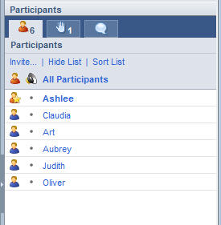

- In the “Invite New Attendee” window, enter the Participant's name and Company name. Check the Send E-Mail Invitation box and provide the Participant's e-mail address. Click the “Invite” button (Figure B).

Figure B
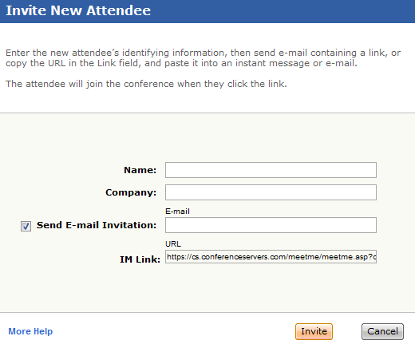

- You may also send an Instant Message (IM) or a separate email invitation by copying the “IM Link” and pasting it into your IM interface or email. The link contains everything the Participant will need to join with one click (Figure B).

To Lock a Conference

The Lock is used to close conference attendance so that no other participants can log in.

- From the Stop pull-down menu, select LOCK session (Figure A). While the conference is locked, no additional Participants can join.

Figure A

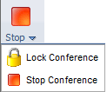

Hand Raise

A Participant can click on the Raise Hand icon on the Participant Toolbar to raise a hand. The participant can click the same icon again to lower the hand.

The Presenter can click the Hand Raise tab to view a list of Participants with their hand raised. Clicking a Participant in the list lowers the Participant's hand.

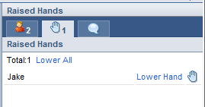

Polling

Adding a Polling Question:

- Poll questions can be added prior to a conference or on the fly. To add a polling question, click the POLLING button in the toolbar.
- A “Polling” dialog box will open (Figure A).

Figure A
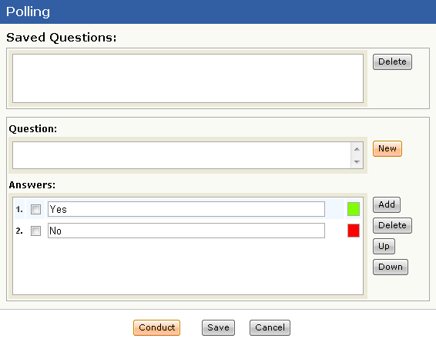

- Type the question you would like to ask into the Question box (Figure A).
- Type the choices you would like to offer into the Answers box (Figure A).
  - You can add additional choices by clicking the Add button on the right side.
  - You can also delete choices by clicking the Delete button on the right side.
  - If you would like the choices to appear in a different order, simply select the choice you would like to move and choose the Up or Down button.
- Once you have the question exactly as you would like it to appear, click the SAVE button located at the bottom of the dialog box (Figure A).
- The question will now appear in the Saved Questions window (Figure B).

Figure B
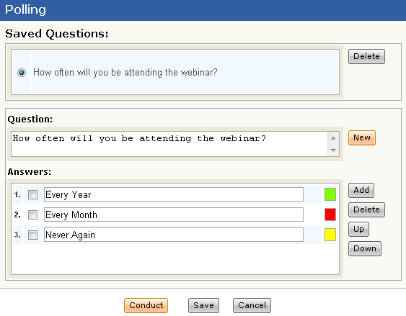

- You can add another question by clicking on the NEW button located on the right hand side beside the Question box.
- You can save as many questions as you would like.

Conducting a Poll

- To conduct a poll, your session must be started.
- Click on the POLLING button.
- The Polling Dialog box will appear. (Figure C)
- Select the Saved Question you would like to push out to your participants and click on the CONDUCT button located at the bottom of the screen.
- You can also create a question on the fly and conduct it right away. To do so, follow the steps above regarding adding a polling question. Once you have the question exactly as you would like it, simply click the Conduct button.
Figure C
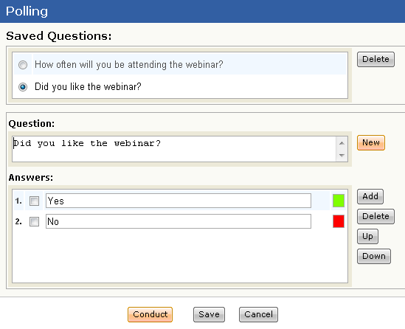

- Once you click the conduct button, a new box will open showing your Question along with the Results (Figure D). As votes come in, you will see the number of votes for each answer as well as the percentage of votes each particular answer has received.
Figure D
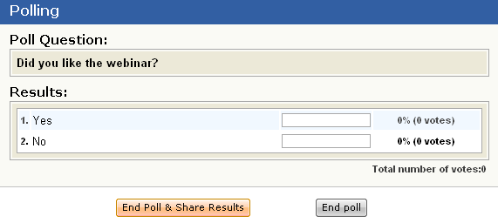

- Once you give your participants a minute or two to select their response, you can end the poll. When you end, you have the choice of whether to share the results of the poll with everyone or keep the results private.
  - To Share the Results with everyone, simply click on the END POLL & SHARE RESULTS button. This will show all of the participants a screen with the percentage of votes for each answer.
    - When you want to stop showing the results, simply click on the END POLL button (Figure E). You will receive a dialogue that will ask for your confirmation of ending the poll and you can click OK (Figure F). This will take you back to the original “Polling” dialog box.
    - You also have the opportunity to print the results as well (Figure E).

Figure E
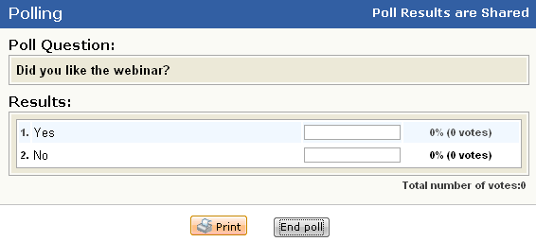

Figure F
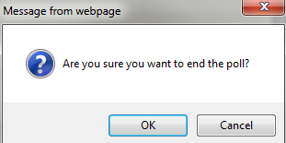

  - To End the Poll without sharing the results, simply click the END POLL button. You will receive a dialogue that will ask for your confirmation of ending the poll and you can click OK (Figure F). This will take you back to the original “Polling” dialog box.
- To stop polling and go back to your presentation, click the CANCEL button from the original “Polling” dialogue box (Figure G).

Figure G
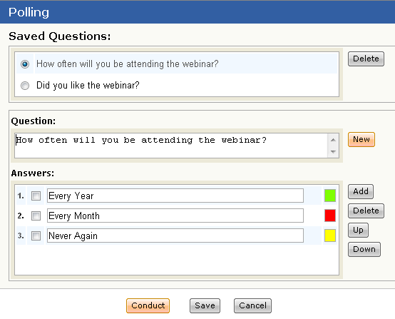
.

Chatting

- On the right side of the screen where you see the Participant Roster, you will see 3 tabs at the top of the Roster. (Figure A)
- Click on the Chat Tab (Figure A).
Figure A
- A chat screen will open.
- At the bottom of the chat screen, you will see a drop down menu. This drop down will allow you to choose who to send a message to (Figure B).
Figure B
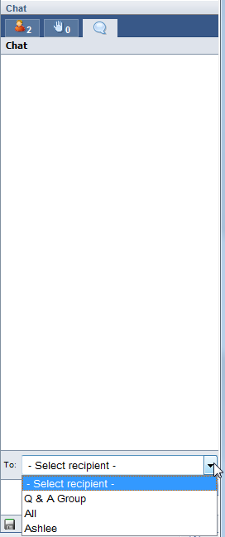

- The choices you have when deciding who to send a chat to are: Q&A Group, All, or you can send a private chat to any of your individual participants. See below for an explanation of each of these choices.
  - Q&A Group – This is the group of participants that have been assigned by the Chairperson allowing them to receive Q&A Questions. (See the Participant Control Features Section) *** Note: Participants do not have a choice and can only send chat messages to the Q&A Group unless their Q&A Rights were managed.
  - All – This sends a chat message to All of your participants.
  - Individual Participant – The drop down menu will also show you a list of all of your current participants. You can choose any of these participants to message privately.

- Once you have selected who to send the chat message to, you can then type your message into the chat box located beneath the drop down menu (Figure C).
Figure C
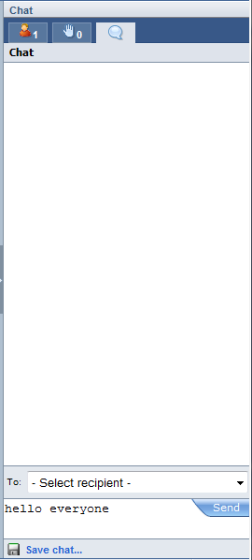

- Your chat history will appear in the white box below the tabs.
Figure D
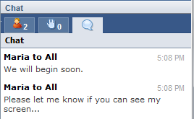
- You also have the option to save your chat by clicking the SAVE CHAT button.

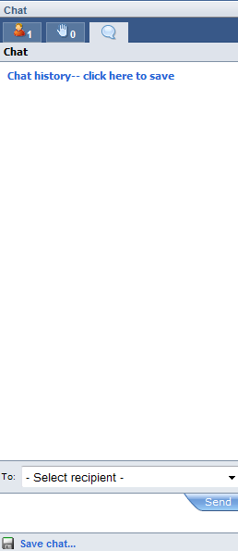

- Click on the Chat history—click here to save link that appears on the chat box to continue with the saving process. A dialogue box will appear confirming what you would like to do, either Open or Save. If you click on OPEN, then your chat history will appear in notepad. If you click on SAVE then your chat history will save as a text document.

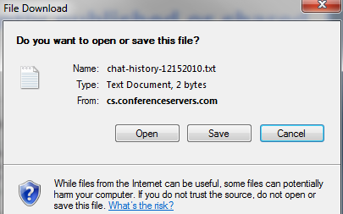

On Demand Recording

There are two ways to record your Web conference: a Full-Service Recording, by making an advanced reservation with Infinite Conferencing, or an On-Demand Recording. With the On-Demand Recording service, you are in complete control. You can record your WebInterpoint session along with your audio on the fly with just a few clicks.

To begin, click the RECORD button on the toolbar. This will bring up the Terms and Conditions page. Also, the On-Demand Recording service will NOT capture any of the following: polling, text chat, or displaying of MS Word or Excel files via “Publishing.” Please also note that the files created using On-Demand Recording cannot be edited. If you require any of these features, please use our Full-Service Recording.

Recordings will be archived (stored) on our system for 30 days only; they will be automatically deleted after that. We highly recommend that you download and store them locally soon after making the recording.

NOTE: There are additional usage charges for the On-Demand Recording.

To Start Recording:
- After the conference has been started, click on the RECORD button and the Terms and Conditions will appear (Figure A).
- After you accept the terms and conditions, the Recording Dialog box will open with step by step instructions on how to start recording (Figure B).

Figure A
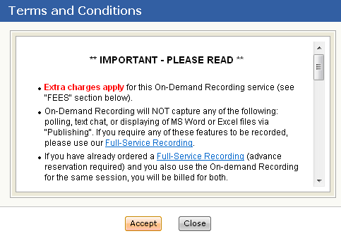
Figure B
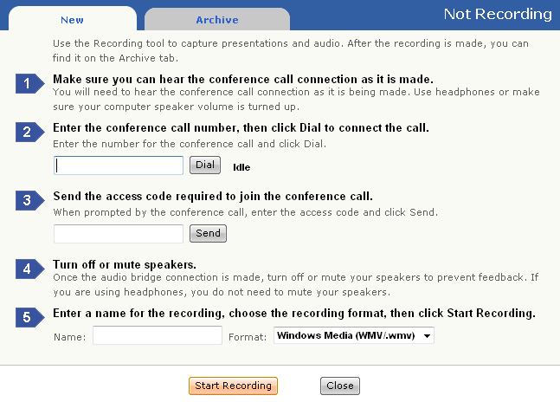

To dial into your audio conference (to obtain the audio for your recording):
Note: If sound is not required, skip to “To start your recording” instructions.

1. Ensure your PC speakers/headphones are turned on and the speaker volume is adequate.
2. Enter the toll-free, dial-in telephone number into the text box under Step 2 and Press the DIAL button (Figure B).
3. The audio bridge auto attendant will be heard from the PC speakers or headphones.
4. When prompted, enter your Participant Entry Code into the text box under Step 3 and press the SEND button. This will join the recording system to the audio conference (Figure B).

To start your recording:
Note: Before you start the recording you should have yourself dialed into the audio conference and also have your PowerPoint slide or application sharing pre-loaded in WebInterpoint. Remember, as soon as you start the recording you are “on air”.

1. Enter a Recording Name into the text box under Step 5. This name will appear in the recording archive once the recording is finished. Also select the format of your recording (Figure B). You have the option to record it as a .mov or .wmv file.
2. Click on the START RECORDING Button (Figure B). A recording icon will appear on the browser status bar at the bottom of the screen (Figure C). The recording window will close automatically to allow for viewing of the conference window.

Figure C

To stop your recording:
Note: If you end your Web conference session without explicitly stopping the recording, the recording will be automatically stopped for you (and saved).
- When you are ready to stop the recording, select either the recording icon in the status bar on the bottom of the screen or the RECORD button in the toolbar.
- The “Recording” box will appear with the option to stop recording.
- Click the STOP RECORDING Button (Figure D).

Figure D
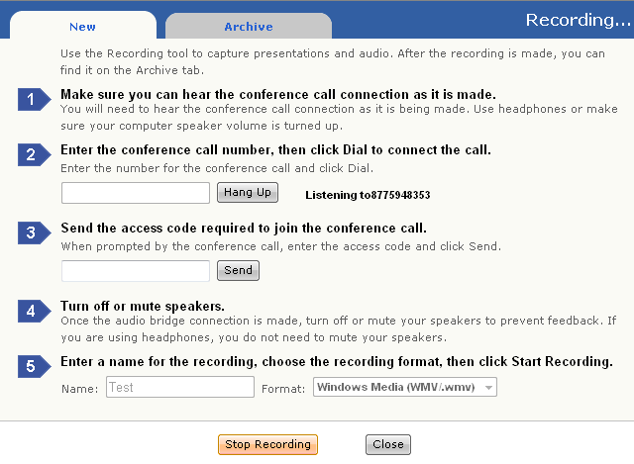

To download and play a recording:
- Log in to your conference. You do not have to start the conference to access the recording archive.
- Click RECORD on the toolbar.
- Click on the ARCHIVE tab to see a list of your recorded conferences in a table (Figure E).
- Locate the recording that you want to download, and then select DOWNLOAD to save it to a folder on your local drive.
- Go to the folder on your local drive that contains the file.
- Double-click the file to play it.
Note: You can also delete a recording from the archive. In the archive list, look for the delete option besides the recording.
Figure E
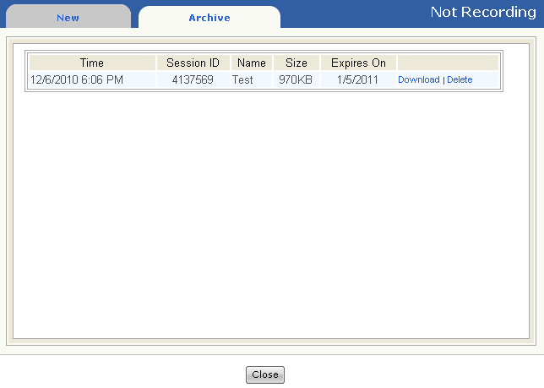

Ending a Conference

When you are finished with your presentation:

- Click the STOP button on the toolbar to conclude the conference and disconnect all participants. You will receive a “Confirm” dialogue box and you can click OK (Figure A). At this point, you are still logged in and can start a new conference.

Figure A
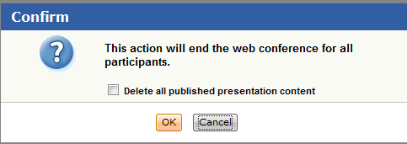

- If you are finished, you can log out of your account using the SIGN OUT button on the toolbar. You will also receive the same Confirm dialogue box as Figure A and once you click OK, it will shut down completely.

